Java Interview Questions
- What is Microservices Architecture.
Microservices architecture is an approach to software development where a complex application is broken down into smaller, independently deployable services. These services are designed to be loosely coupled, allowing for independent development, scaling, and maintenance. Microservices communicate through APIs and can be built with different technologies. This architecture promotes agility, scalability, and continuous deployment but also requires careful management of distributed systems and inter-service communication.

- What is Monolithic Architecture.
Monolithic architecture is a traditional software design approach where an entire application is built as a single, tightly integrated unit. In a monolith, all components and functions are closely connected, making development and deployment more straightforward but potentially limiting scalability and agility.

- Difference between Monolithic Architecture & Microservices Architecture.

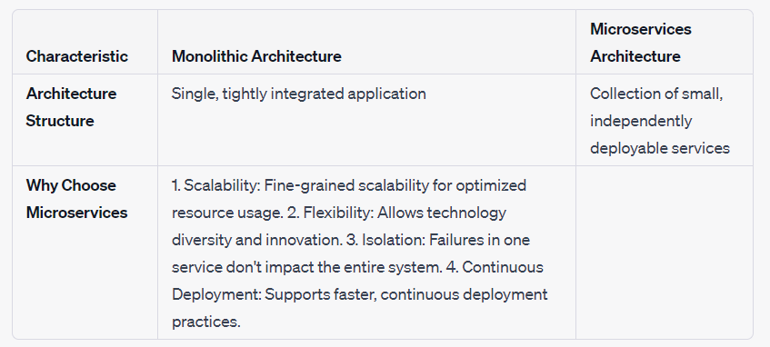

- Consider I've 3 microservices, M1, M2 & M3, now M1 calls M2 and upon successful acknowledgement, M1 calls M3 & after successful response from M3, M1 sends the successful response, consider there are database operations in each microservices, now what M1 called M2 & gets successful response or updated the respective database for M1 & M2 now M1 called M3 and M3 was unavailable, what will happen & how the transaction will be managed?

In a microservices architecture, handling transactions and ensuring data consistency across multiple microservices can be challenging, especially when one microservice depends on the successful completion of another. In your scenario, if M1 calls M2, updates its database successfully, and then calls M3, but M3 is unavailable or fails to respond, you are faced with a situation that requires careful consideration.

Here's how you might manage this situation:

- Compensating Transactions:
  - One common approach to handle such scenarios is to implement compensating transactions or compensation logic. In this case, when M1 calls M2 and updates its database, it should record information or execute actions that allow it to revert the changes in case M3 cannot be reached or fails. This ensures that if the overall transaction cannot be completed, any partial changes made by M1 and M2 can be rolled back.
- Asynchronous Communication:
  - Consider making the communication between M1, M2, and M3 asynchronous. Instead of waiting for an immediate response from M3, M1 could send a message or an event to a message broker or queue, indicating that M3 should perform a certain action. M3 can then process the request whenever it becomes available. This decouples the timing of operations and reduces the risk of synchronous failures.
- Idempotent Operations:
  - Ensure that the operations performed by M2 and M3 are idempotent. In other words, performing the same operation multiple times should have the same effect as performing it once. This property makes it safer to retry operations in case of failures without causing unintended side effects.
- Retry Mechanisms:
  - Implement retry mechanisms in M1 to periodically retry the call to M3 if it initially fails. However, be cautious about setting reasonable retry intervals and limits to avoid overloading the unresponsive microservice.
- Monitoring and Alerting:
  - Implement robust monitoring and alerting systems to detect when M3 becomes unavailable. This allows you to respond proactively and investigate the root cause of the issue.
- Manual Intervention:
  - In extreme cases where automated recovery is not possible, consider having a process for manual intervention. Human operators can assess the situation, make decisions, and potentially perform data corrections.
- Logging and Audit Trails:
  - Maintain detailed logs and audit trails of all transactions and interactions between microservices. This helps in troubleshooting and identifying the state of each service at different points in time.
- Rollback Procedures:
  - Define rollback procedures that can be initiated by M1 in case of a failure in the overall transaction. These procedures should revert any changes made by M1 and M2, ensuring data consistency.

- What is Asynchronous Communication in Microservices Architecture & how it can be achieved.
- Asynchronous communication in microservices is a messaging approach where services exchange information without waiting for an immediate response. This is achieved through techniques like message queues, publish-subscribe, or event-driven architecture. It enables decoupled, scalable, and fault-tolerant interactions between microservices, enhancing system responsiveness and resource efficiency.
- Message queues, such as RabbitMQ and Kafka, play a pivotal role in enabling asynchronous communication between microservices. These queues work by allowing one microservice to send messages (or events) to a central queue, which acts as an intermediary. Other microservices can then consume these messages from the queue when they are ready, independently and asynchronously. This approach decouples the sender and receiver, enabling more responsive, scalable, and fault-tolerant interactions in a microservices architecture.

- What does Stateless Service means?
A stateless service in the context of microservices refers to a service that does not store any client-specific data or state information between requests. Each client request is self-contained and contains all the information needed for processing. Each request to a stateless service is treated independently, and the service does not rely on previous requests or maintain session data. Stateless services are easier to scale horizontally, making them well-suited for microservices architectures where services need to be flexible, shareable, and easily replaceable.

- What does Idempotent mean in Microservice Architecture.
In Microservices Architecture, "idempotent" means that performing the same action multiple times has the same result as performing it once. It ensures that even if a request is repeated or fails and is retried, the system's state remains unchanged or consistent. This property simplifies error handling and ensures predictable behavior, making it a crucial concept for robust microservices interactions.

- What major changes has been introduced to Collection Framework in Java 8.

Java 8 introduced several major changes and enhancements to the Collection Framework, focusing on improving expressiveness, readability, and functionality. The most notable changes in Java 8's Collection Framework include:

- Introduction of Streams: Java 8 introduced the concept of streams, which are a sequence of elements that can be processed in a functional style. Streams enable you to perform operations such as filtering, mapping, and reducing on collections of data easily and efficiently.

- Lambda Expressions: Lambda expressions were introduced in Java 8, and they greatly improved the readability and conciseness of code when working with collections. Lambda expressions can be used with functional interfaces (e.g., `Predicate`, `Function`) to define behaviour in a more compact way.

- Default Methods: Default methods were added to interfaces in Java 8, allowing the addition of new methods to existing interfaces without breaking backward compatibility. This feature was used extensively in the Collection Framework, adding methods like `forEach`, `removeIf`, and `spliterator` to various collection interfaces.

- Method References: Method references provide a shorthand notation for invoking methods through a lambda expression. This feature enhances code readability when working with collections.

- New Collection Methods: Java 8 introduced several new methods in the `Collection` interface, including `stream()`, `parallelStream()`, and `removeIf()`. These methods provide convenient ways to work with collections using streams and predicates.

- New `Map` Methods: The `Map` interface gained several new methods, such as `forEach`, `getOrDefault`, `putIfAbsent`, `compute`, and `merge`, making it easier to work with key-value pairs.
- New `List` Methods: The `List` interface received new methods like `sort` and `replaceAll` to facilitate sorting and bulk replacement of elements in lists.

- `java.util.function` Package: Java 8 introduced the `java.util.function` package, which includes functional interfaces like `Predicate`, `Function`, `Consumer`, and `Supplier`. These interfaces are commonly used when working with streams and lambdas in the Collection Framework.

- Enhanced `Comparator`: The `Comparator` interface was enhanced with new methods like `reversed()`, `thenComparing()`, and `nullsFirst()/nullsLast()` to provide more flexible sorting options.

- What are the major changes which are introduced in Java 8. (Features of Java 8)

Java 8 introduced several major features and enhancements to the Java programming language. Here are the key changes introduced in Java 8:

- Lambda Expressions: Java 8 introduced lambda expressions, which are a concise way to represent anonymous functions or methods. Lambda expressions improve code readability and enable the use of functional programming paradigms in Java.

- Functional Interfaces: Functional interfaces are interfaces with a single abstract method, and Java 8 introduced the `@FunctionalInterface` annotation to indicate such interfaces. Functional interfaces are crucial for lambda expressions.

- Default Methods: Java 8 introduced default methods in interfaces, allowing the addition of new methods to interfaces without breaking backward compatibility. This feature helps extend interfaces in libraries and frameworks.

- Method References: Method references provide a shorthand notation for invoking methods through a lambda expression. They make code more concise and readable.

- Streams API: The Streams API allows for functional-style operations on sequences of elements, such as collections or arrays. Streams enable operations like filtering, mapping, reducing, and parallel processing, making code more expressive and efficient.

- Functional Interfaces: Java 8 introduced a set of predefined functional interfaces in the `java.util.function` package, including `Predicate`, `Function`, `Consumer`, and `Supplier`. These interfaces are widely used with lambda expressions and streams.

- Date and Time API: Java 8 introduced the `java.time` package, providing a modern date and time API that addresses the limitations of the old `java.util.Date` and `java.util.Calendar` classes.

- CompletableFuture: The `CompletableFuture` class was introduced to support asynchronous programming and handle asynchronous tasks with ease. It provides methods for chaining asynchronous operations.

- New `java.util.Optional` Class: The `Optional` class was introduced to represent the presence or absence of a value, reducing the risk of null pointer exceptions.
- New Collectors: Java 8 added several new collectors to the Streams API, enabling operations like grouping, partitioning, and custom reduction.

- Concurrent Accumulators: The `java.util.concurrent` package introduced the `LongAccumulator` and `DoubleAccumulator` classes for concurrent, non-blocking accumulations.

- Improved `java.util.Arrays`: The `java.util.Arrays` class received new methods for sorting arrays, comparing arrays, and creating parallel arrays.

- Explain Stream API in Java 8.

The Stream API in Java 8 is a powerful and expressive feature that allows you to perform functional-style operations on collections (or other data sources) in a declarative manner. It was introduced to simplify and enhance the manipulation of data by providing a more concise and readable way to work with collections. The Stream API is part of the Java Collections Framework and is found in the `java.util.stream` package.

Key characteristics and capabilities of the Stream API in Java 8 include:
- Functional Programming Paradigm: The Stream API promotes functional programming principles by allowing you to perform operations on data as if you were specifying what to do, rather than how to do it. This leads to more readable and maintainable code.

- Lazy Evaluation: Streams use lazy evaluation, which means that data is processed on-demand, and intermediate operations (e.g., filtering, mapping) are not executed until a terminal operation (e.g., `forEach`, `collect`) is called. This can lead to improved performance and efficiency.

- Pipelines: You can create complex data-processing pipelines by chaining multiple stream operations together. This allows you to filter, transform, aggregate, and process data in a fluent and sequential manner.

- Immutable: Streams themselves do not modify the source data. Instead, they produce new streams or collections as a result of operations, ensuring that the original data remains unchanged.

- Parallel Processing: Streams can take advantage of multi-core processors by using parallel streams. You can easily switch between sequential and parallel modes to optimize performance for different use cases.

- Operations:
  - Intermediate Operations: These operations (e.g., `filter`, `map`, `sorted`) transform a stream into another stream. They are typically followed by a terminal operation.
  - Terminal Operations: These operations (e.g., `forEach`, `collect`, `reduce`) produce a result or a side-effect and trigger the actual processing of data in the stream.

- Common Stream Operations:
  - `filter`: Filters elements based on a specified condition.
  - `map`: Transforms elements into a new form.
  - `reduce`: Combines elements to produce a single result.
  - `forEach`: Applies an action to each element.
  - `collect`: Gathers elements into a collection.
  - `sorted`: Sorts elements based on a specified comparator.
  - `distinct`: Removes duplicate elements.
  - `flatMap`: Flattens nested streams into a single stream.

- Data Sources: Streams can be created from various data sources, including collections, arrays, I/O channels, and even dynamically generated data.

- Integration with Collections: Streams can be easily integrated with existing collection classes, allowing you to transform and process data without changing the underlying collection.

- Parallel Streams: Parallel streams allow for concurrent processing of data, which can result in improved performance for computationally intensive tasks.

- Object class & it's methods in Java.
1. equals(Object obj)
2. hashCode()
3. toString()
4. getClass()
5. clone()
6. finalize()
7. wait()
8. wait(long timeout)
9. wait(long timeout, int nanos)
10. notify()
11. notifyAll()

- Why wait() & notify() are in Object Class instead of Thread Class.

- The wait() and notify() methods are defined in the Object class in Java because they are used for inter-thread communication. These methods allow threads to communicate with each other when they are waiting for the same monitor.
- If the wait() and notify() methods were defined in the Thread class, each thread would need to know the status of every other thread. This would create problems with thread communication and synchronization on the object.
- The wait() and notify() methods are also a synchronization mechanism. They allow one thread to communicate to another thread that a particular condition has occurred.

- Why wait(), notify() & notifyAll() are always called from Synchronized Block.

- The wait(), notify(), and notifyAll() methods in Java are used to synchronize access to shared resources. They are always called from within a synchronized block or method to ensure that the threads that are using the shared resource do not interfere with each other.
- If these methods were not called from within a synchronized block or method, it would be possible for one thread to call one of these methods while another thread was in the middle of accessing the shared resource. This could lead to data corruption or other errors.
- By calling these methods from within a synchronized block or method, the Java Virtual Machine ensures that only one thread can access the shared resource at a time. This prevents data corruption and other errors and ensures that the threads cooperate properly.

- Is it possible to call wait(), notify() & notifyAll() are always called from non-Synchronized Block.

- It is technically possible to call the wait(), notify(), and notifyAll() methods from an unsynchronized block in Java. However, this is not recommended, as it can lead to data corruption and other errors.
- When a thread calls one of these methods from an unsynchronized block, it is possible for another thread to call one of these methods while the first thread is in the middle of accessing the shared resource. This can lead to data corruption or other errors.
- To avoid these problems, it is important to always call the wait(), notify(), and notifyAll() methods from within a synchronized block or method. This ensures that only one thread can access the shared resource at a time.

- What is Functional Interface.
- An Interface that contains exactly one abstract method is known as functional interface. It can have any number of default, static methods but can contain only one abstract method. It can also declare methods of object class.

- Functional Interface is also known as Single Abstract Method Interfaces or SAM Interfaces. It is a new feature in Java, which helps to achieve functional programming approach.

- If I annotate an interface with @FunctionalInterface which is having more than 1 abstract method it will result in a Compilation Error.

- Java 8 introduced the `java.util.function` package, which includes functional interfaces like `Predicate`, `Function`, `Consumer`, and `Supplier`.

- Exception Hierarchy in Java.

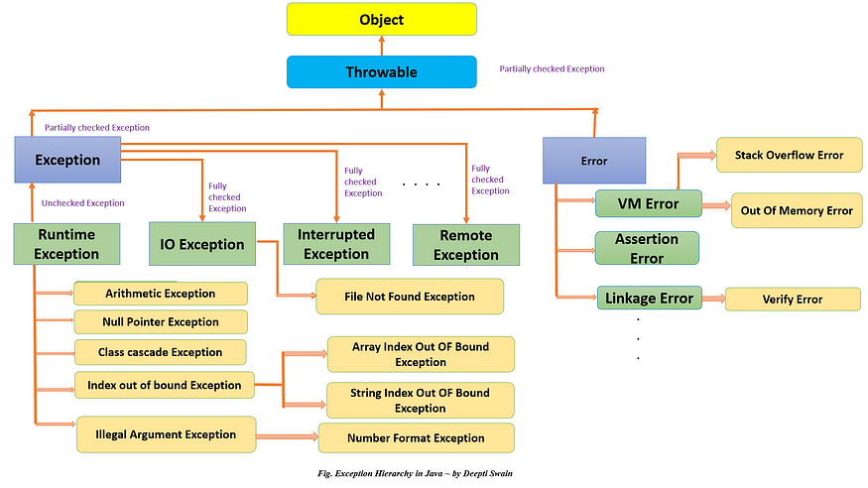
- Difference between Checked & Unchecked Exceptions.

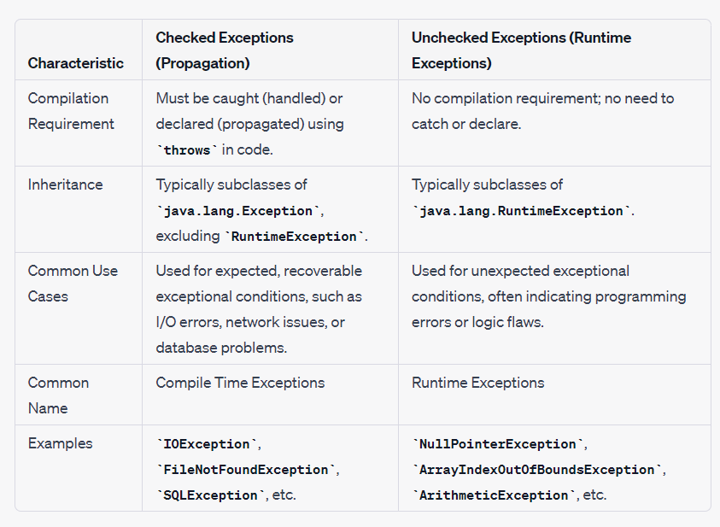

- Difference between HashMap & HashTable.
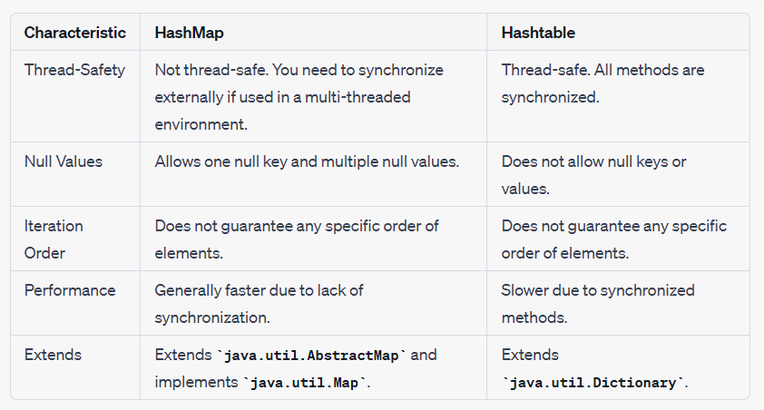

- Difference between throw & throws

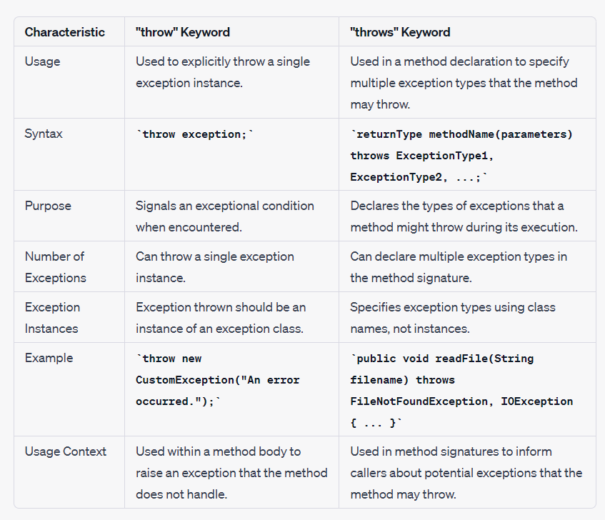

- Collection Hierarchy in Java.

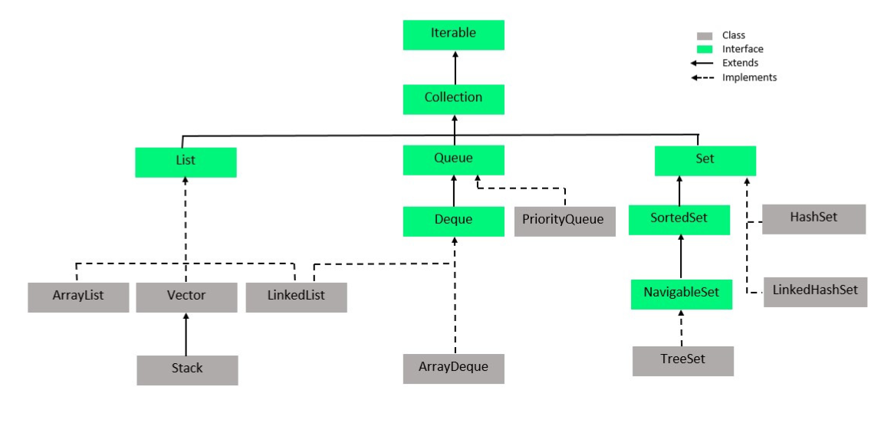
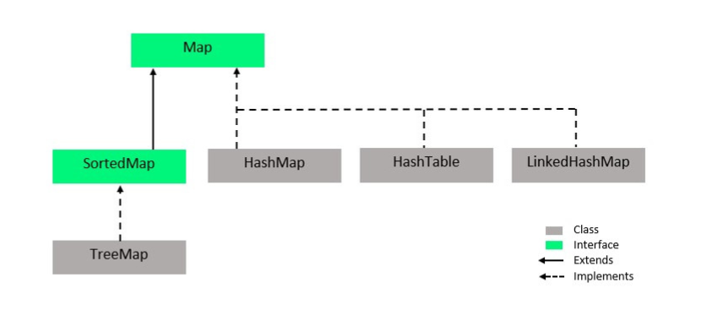

- Difference between HashMap & ConcurrentHashMap.
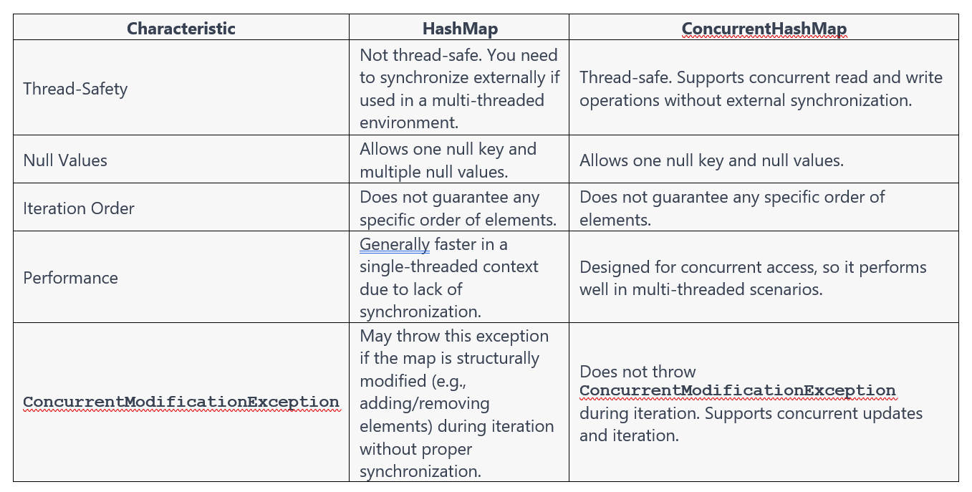

- What is first class objects in Java.
- A first-class object in Java is an object that can be treated as a value, such that it can be assigned to a variable, passed as an argument to a function, or returned from a function.
- In Java, all primitive data types (int, double, char, etc.) and strings are first-class objects. This means that they can be assigned to variables, passed as arguments to functions, and returned from functions.
- Strings are first-class objects in Java. This means that they can be assigned to variables, passed as arguments to functions, and returned from functions.

- How to synchronize an ArrayList in Java.
Using Collections.synchronizedList()
Example: List<String> synchronizedList = Collections.synchronizedList(new ArrayList<>());

- Why can’t we sort HashSet using Collections.sort() method.
Sorting requires elements to have a defined order. HashSet does not maintains the insertion order of its elements, hence sorting of HashSet is not possible.
- Difference between ConcurrentHashMap & SynchronizedMap.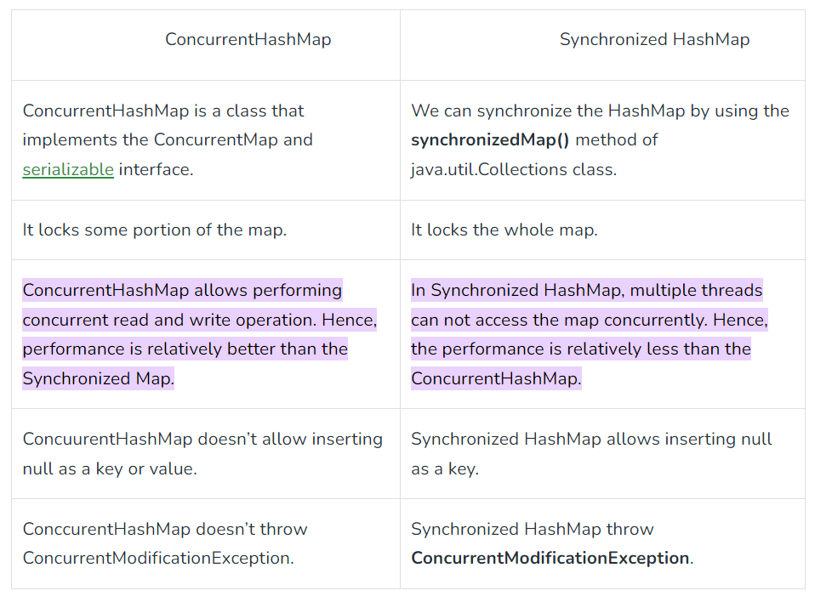

- Difference between Arrays & ArrayList in Java.

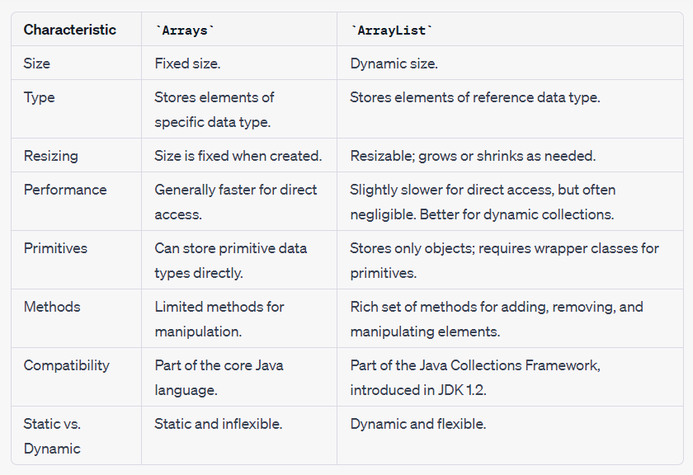
- Difference between List & Set in Java.

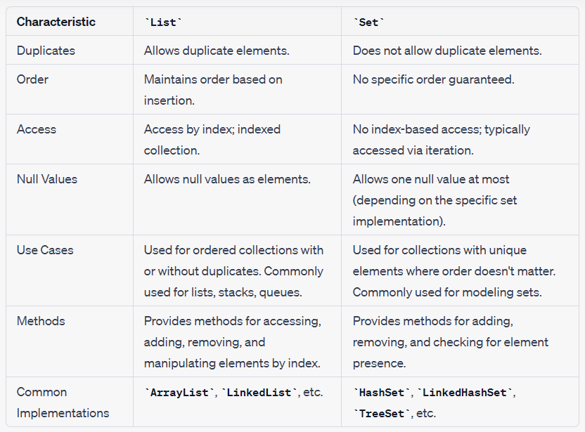

- Difference between HashSet & HashMap in Java.

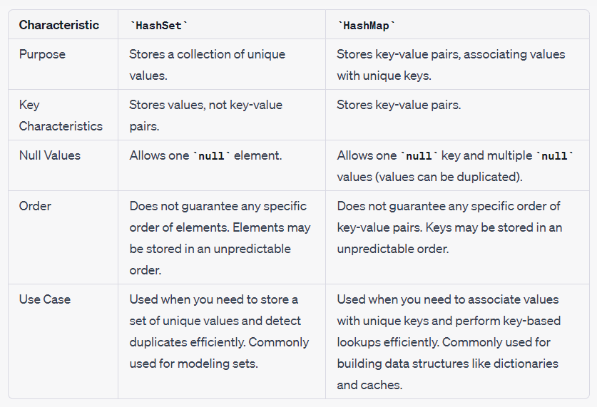
- Difference between Collection Interface & Collections Class in Java.
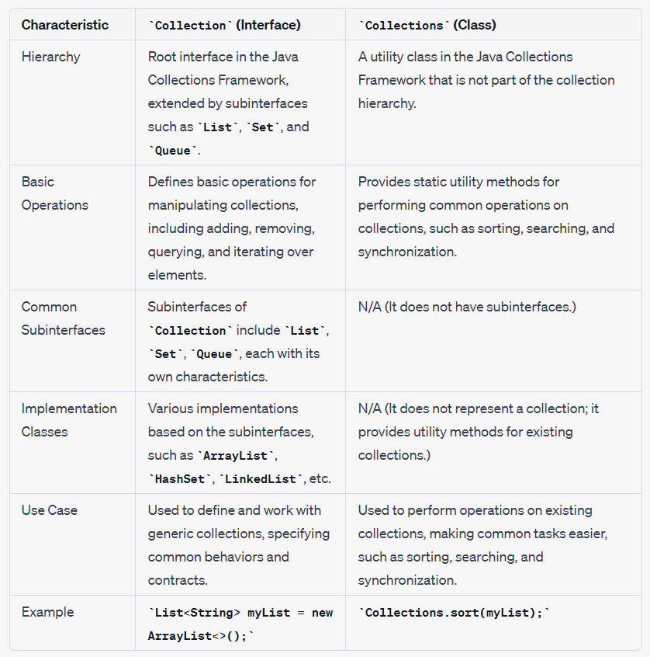

- Difference between fail-fast & fail-safe.
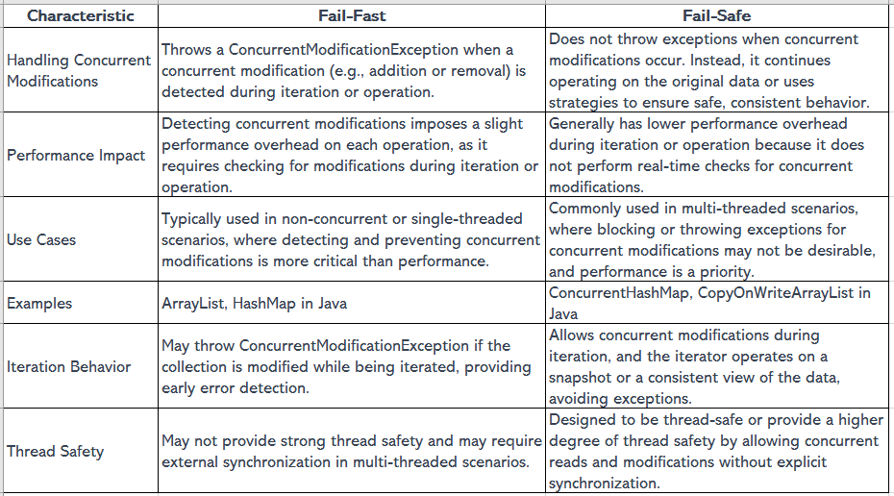
- Comparison between List, Set & Map.
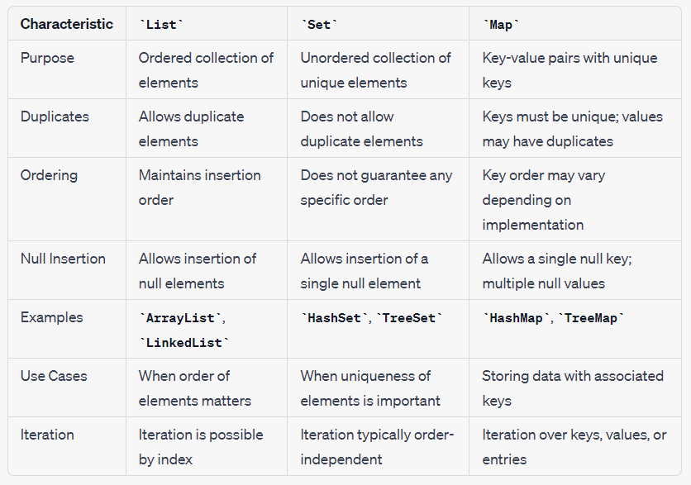

- Explain ParallelStream in Java 8.
- The `parallelStream` is a feature or an extension of the Stream API that allows you to perform parallel processing of data in a collection.
- It is designed to leverage multi-core processors and make it easier to perform operations concurrently on large datasets.
- It divides the data into multiple chunks and processes each chunk concurrently on separate threads.

- Explain Spring Boot Actuator.
Spring Boot Actuator is a set of production-ready features for monitoring and managing applications. It includes health checks, metrics, and application information.

Here are some of the important and commonly used endpoints provided by Spring Boot Actuator:

- `/actuator/health`:
  - This endpoint provides information about the application's health.
  - It can be used for basic health checks and to determine if the application is up and running.
  - Response can include information such as "status" (UP or DOWN), disk space, database connectivity, and custom health indicators.

- `/actuator/info`:
  - This endpoint allows you to expose custom application-specific information.
  - You can configure and provide custom details like version, description, and any other metadata about your application.

- `/actuator/metrics`:
  - Metrics endpoint provides various application metrics such as memory usage, garbage collection stats, and HTTP request metrics.
  - You can monitor the performance and resource utilization of your application.

- `/actuator/env`:
  - The environment endpoint provides information about the application's environment properties and configuration.
  - It's useful for debugging and understanding the configuration properties currently in effect.

- `/actuator/loggers`:
  - The loggers endpoint allows you to view and dynamically modify the logging levels of different components in your application.
  - You can change log levels at runtime without requiring a restart, which is helpful for troubleshooting.

- `/actuator/auditevents`:
  - This endpoint provides information about security-related audit events in your application.
  - It's useful for auditing and monitoring authentication and authorization activities.

- `/actuator/httptrace`:
  - The httptrace endpoint offers information about HTTP requests and responses.
  - You can see details like request and response headers, status codes, and timing information.
  - Useful for diagnosing issues with HTTP requests and responses.

- `/actuator/threaddump`:
  - The threaddump endpoint provides a thread dump of the application, which can be helpful for diagnosing thread-related issues, such as deadlocks.

- `/actuator/prometheus`:
  - The Prometheus endpoint exposes metrics in a format that can be scraped by Prometheus, a popular monitoring tool.
  - It allows you to collect and visualize application metrics over time.

- `/actuator/shutdown`:
  - The shutdown endpoint allows you to gracefully shut down the Spring Boot application.
  - It can be configured with proper security measures to prevent unauthorized access.

- `/actuator/beans`:
  - The beans endpoint provides a list of all Spring beans currently registered in the application context.
  - Useful for inspecting the beans configured in your application.

- `/actuator/mappings`:
  - The mappings endpoint shows a list of all the HTTP request mappings in your application.
  - It helps in understanding how different endpoints are mapped to controller methods.

When using these endpoints, be mindful of security considerations and ensure that sensitive information is protected. You can customize Actuator endpoints and their behaviour through configuration.

- Explain SOLID Principle.

- Single Responsibility Principle (SRP):
  - Principle: This principle emphasizes that a class should have a single, well-defined responsibility or job.
  - Explanation: This principle emphasizes that a class should have a single, well-defined responsibility or job. If a class has multiple responsibilities, it becomes more challenging to understand, maintain, and modify. Splitting responsibilities into separate classes improves code maintainability and reduces the risk of unintended side effects when making changes.

- Open-Closed Principle (OCP):
  - Principle: Software entities (classes, modules, functions) should be open for extension but closed for modification.
  - Explanation: This principle encourages the creation of code that can be extended without modifying its existing source code. It promotes the use of interfaces, abstract classes, and inheritance to add new functionality or behaviour rather than altering existing code. This leads to code that is more robust and less prone to introducing bugs when changes are made.

- Liskov Substitution Principle (LSP):
  - Principle: Subtypes must be substitutable for their base types without altering the correctness of the program.
  - Explanation: In essence, this principle ensures that derived classes or subclasses should be able to replace instances of their parent classes without causing errors or unexpected behaviour. Violations of this principle can lead to unexpected issues when using polymorphism. Adherence to LSP promotes code that is predictable and consistent when using inheritance.
  - Practical Example: In practical terms, this means that a subclass should override or extend the methods of its superclass in a way that preserves the expected behaviour of those methods. It should not introduce new behaviours that are incompatible with the contract of the superclass. This ensures that code relying on the superclass can work seamlessly with instances of the subclass.

- Interface Segregation Principle (ISP):
  - Principle: Clients should not be forced to depend on interfaces they do not use.
  - Explanation: This principle advises breaking large, monolithic interfaces into smaller, more specific ones. It ensures that classes only depend on the methods they actually need from an interface, reducing unnecessary dependencies and potential conflicts. Smaller, focused interfaces make it easier to create cohesive and maintainable classes.

- Dependency Inversion Principle (DIP):
  - Principle: High-level modules should not depend on low-level modules. Both should depend on abstractions.
  - Explanation: DIP encourages the use of abstractions (such as interfaces or abstract classes) to decouple high-level modules (business logic) from low-level modules (implementation details). By depending on abstractions rather than concrete implementations, changes to low-level modules do not impact high-level modules. This principle enables more flexible and extensible code and facilitates unit testing and inversion of control (IoC) patterns.

These SOLID principles, when followed diligently, lead to code that is easier to maintain, extend, and test. They promote good object-oriented design practices and help reduce the complexity and fragility of software systems. Adhering to these principles can result in more robust and adaptable codebases, making it easier to accommodate changes and enhancements over time.

- Why we use Interface in Java.

- Multiple Inheritance: Java supports single inheritance, but a class can implement multiple interfaces. This allows a class to inherit behavior and contract from multiple sources, enabling a form of multiple inheritance and enhancing code modularity and flexibility.

- Polymorphism and Reusability: Interfaces enable polymorphism, allowing different objects that implement the same interface to be used interchangeably. This promotes code reusability, adaptability, and the writing of more generic and adaptable code.

- Difference between @PathVariable & @RequestParam.

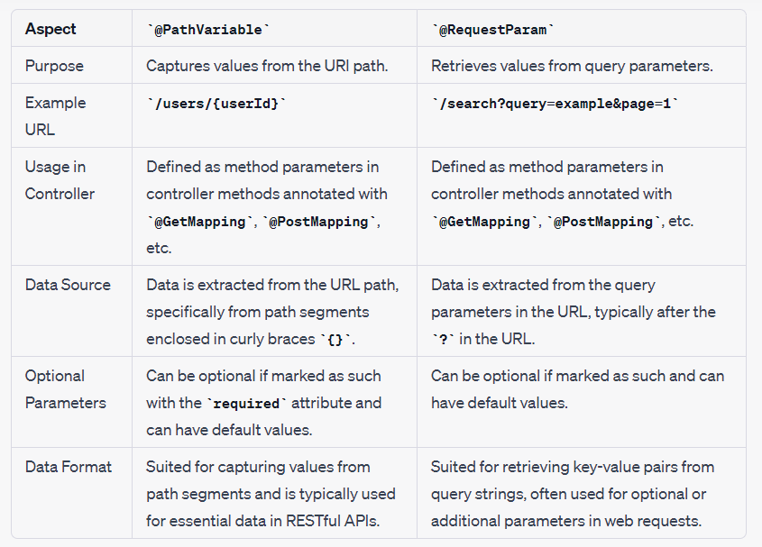

- Difference between ArrayList & LinkedList in Java.

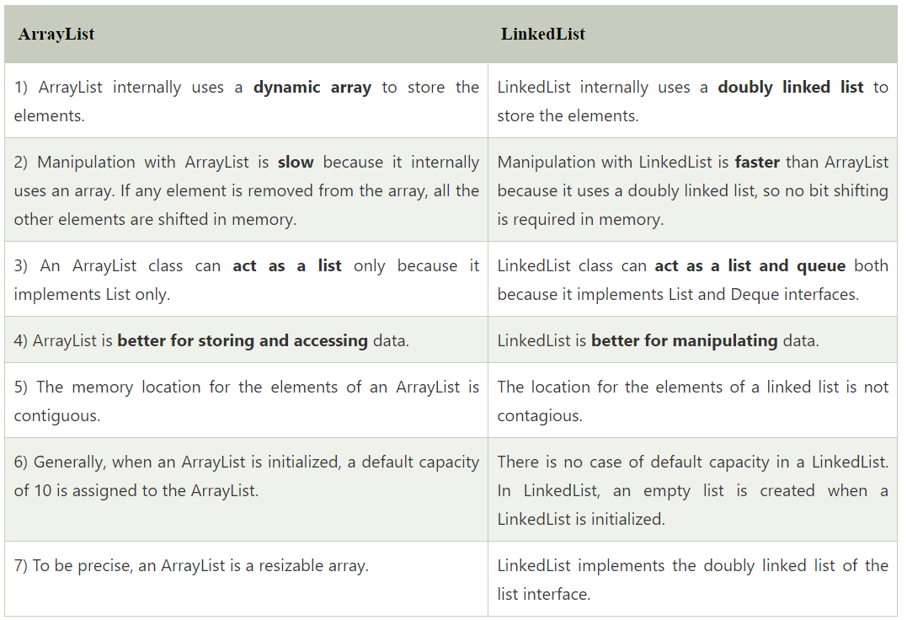

- Load Factor, Default Capacity & Growth ratio of an ArrayList, HashMap & HashSet.

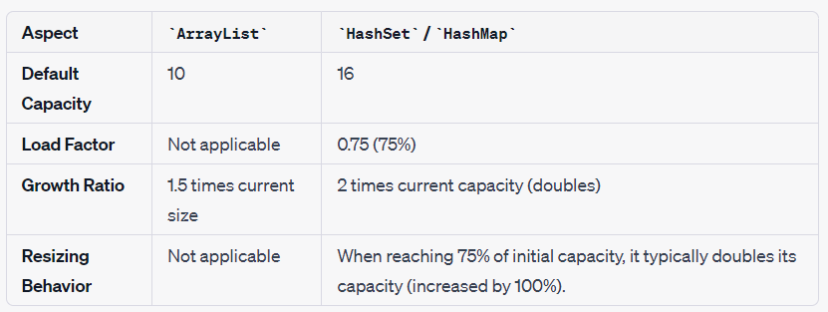

- If an ArrayList doesn’t have any load factor, how it resizes when an 11th element enters.

In Java, `ArrayList` doesn't have a load factor concept like `HashSet` or `HashMap`. `ArrayList` is backed by an array, and it resizes by creating a new array with a larger capacity when it runs out of space to accommodate new elements.

When you add the 11th element to an `ArrayList`, the following happens:

- The `ArrayList` checks if there's enough space in its internal array to accommodate the new element.

- If there is enough space, it simply adds the element to the array at the next available index.
- If there isn't enough space, it creates a new array with a larger capacity. The default behavior is to increase the capacity by 50% (1.5 times) of the current capacity.
- It then copies the elements from the old array to the new array.
- Finally, it adds the new element to the new array.

This resizing operation can be relatively expensive, as it involves copying elements from the old array to the new one. However, it ensures that `ArrayList` can dynamically grow to accommodate more elements as needed.

- Can we enter duplicates in Set, what if we try to enter duplicate values, what will happen.
- Sets do not allow duplicate elements. If you try to add a duplicate element, it will not be added, and the set will remain unchanged.
- When you attempt to add an element to a HashSet, it first computes the hash code of the element. It then uses the hash code to determine the bucket (or location) in which the element should be stored. If the element is not already in the set, it is inserted into the appropriate bucket.
- If there is already an element in that bucket (i.e., there's a hash code collision), the HashSet implementation checks for equality using the equals method. If the new element is equal to an existing element according to the equals method, it is not added again (ignored). If they are not equal, the new element is added.

- HashMap internal working in Java.
- When we create an instance of `HashMap`, it initializes an array with 16 buckets (sometimes called nodes), as 16 is the default initial capacity.
- When we put a key-value pair into a `HashMap` using the `put` method, it calculates the hash code of the key and uses that hash code to determine the index (bucket) where the key-value pair should be stored.
- Each bucket in the array can contain multiple key-value pairs. In older versions of Java, a linked list is used to store these pairs within a bucket. Starting from Java 8, if a bucket exceeds a certain threshold, it switches to using a balanced tree (red-black tree) instead of a linked list to handle collisions.
- If two keys have the same hash code and land in the same bucket, `HashMap` uses the `equals` method to check if they are equal. If they are equal, it updates the value associated with that key. If they are not equal, `HashMap` handles this scenario by adding a new linked node (or tree node) to the bucket to store the additional key-value pair.
- If you put `null` as the key, it will always be stored in the 0th index (bucket) of the array. `HashMap` treats `null` as a special case.

- What new features are added in HashMap in Java 8.

- Balanced Tree for Collisions: In Java 8, `HashMap` uses a balanced tree (red-black tree) instead of a linked list to handle hash collisions when multiple keys map to the same bucket. This change significantly improves worst-case performance from linear (O(n)) to logarithmic (O(log n) in scenarios with many collisions.

- Threshold Control: The transition between a linked list and a tree structure occurs based on predefined thresholds. When the bucket size exceeds a certain threshold (usually 8 elements), it becomes a tree, and when it falls below another threshold (usually 6 elements), it reverts to a linked list.

- `putAll` Optimization: The `putAll` method, used for merging two `HashMap` instances, has been optimized to handle hash collisions more efficiently.

- Functional Computing Methods: Java 8 introduced new methods like `compute`, `computeIfAbsent`, and `computeIfPresent` for performing computations on `HashMap` entries in a more functional and expressive manner.

- `forEach` Method: The `forEach` method allows you to iterate over key-value pairs in a `HashMap` and apply a specified action to each entry.

- Difference between Deep & Shallow copy.

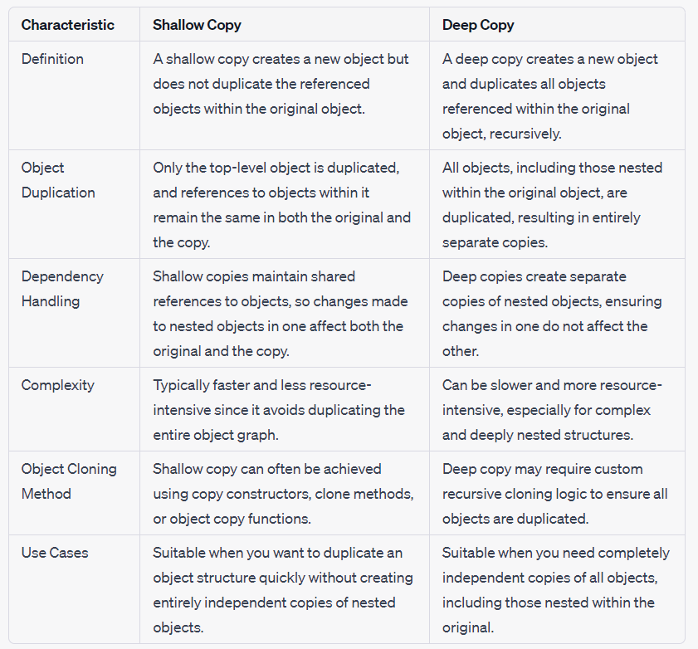

- Where do we use Deep & Shallow copy.

- Shallow Copy Use Cases:

  - Performance Optimization: Shallow copying can be more efficient in terms of memory and processing time when you don't need completely independent copies of objects. For example, when cloning large data structures frequently, creating deep copies of the entire structure might be resource-intensive.

  - Caching: In scenarios where you maintain a cache of objects and want to quickly create a copy for temporary use without affecting the cached object, a shallow copy can be useful.

  - Immutable Objects: If the objects within your data structure are immutable (i.e., their state cannot change), shallow copies are generally sufficient because there's no concern about unintended changes.

  - Prototype Design Pattern: Shallow copying is often used in the prototype design pattern, where you create new objects by copying an existing prototype object. In this case, you might not need deep copies.

- Deep Copy Use Cases:

  - Data Isolation: When you need to ensure that changes made to one copy of an object do not affect other copies, deep copying is essential. For example, in a multi-threaded environment, deep copying can help isolate data access.

  - Serialization: When serializing and deserializing objects, deep copies may be used to create independent copies of objects to maintain data integrity.

  - Cloning Complex Structures: If you have complex object graphs with nested objects, and you want to duplicate the entire structure, deep copying is necessary to ensure that all objects, no matter how deeply nested, are duplicated.

  - Undo/Redo Functionality: In applications that support undo/redo functionality, deep copying can be used to create snapshots of data for potential future restoration.

  - Data Transformation: When transforming data structures, especially during data migration or data manipulation tasks, deep copying may be used to create distinct copies for different transformation stages.

- Difference between Serialization & Deserialization.

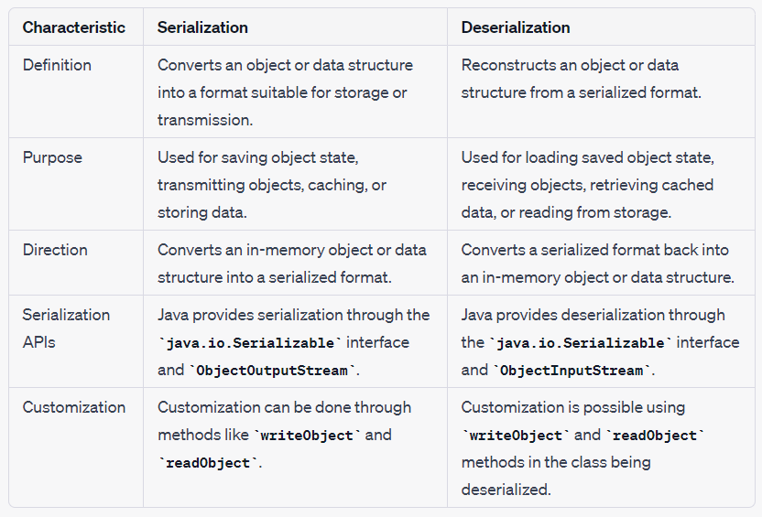

- How Hibernate is better than JDBC.
Hibernate and JDBC are two different approaches for interacting with databases in Java. Here are some reasons why Hibernate is often considered better than raw JDBC in certain scenarios:

- Abstraction of Database Details:
  - Hibernate provides a higher-level object-relational mapping (ORM) framework, which abstracts away low-level JDBC details like managing connections, writing SQL queries, and handling result sets. This abstraction simplifies database interactions and reduces the amount of boilerplate code.

- Productivity:
  - Hibernate can significantly reduce development time because it allows developers to work with Java objects instead of writing SQL queries. This results in more concise and maintainable code.

- Portability:
  - Hibernate offers a level of database portability. You can write Java code using Hibernate, and it will work with different relational databases with minimal changes, thanks to Hibernate's dialects and database abstraction.

- Object-Oriented Approach:
  - Hibernate maps database tables to Java objects, allowing developers to work with data in an object-oriented manner. This is more intuitive for developers who are accustomed to object-oriented programming.

- Automatic Table Creation and Schema Evolution:
  - Hibernate can automatically generate database tables based on the Java entities and manage schema changes over time. This is helpful during development and reduces the need for manual schema management scripts.

- Caching:
  - Hibernate provides caching mechanisms that can significantly improve application performance by reducing database queries. This is especially useful for read-heavy applications.

- Lazy Loading:
  - Hibernate supports lazy loading, which means that it loads related data from the database only when it's explicitly accessed. This can improve application performance by minimizing the amount of data retrieved from the database.

- Query Language:
  - Hibernate Query Language (HQL) allows you to write database queries using an object-oriented syntax, making it more readable and maintainable compared to raw SQL.

- Integration with Other Frameworks:
  - Hibernate can be easily integrated with other Java frameworks like Spring, making it part of a comprehensive technology stack for building enterprise-level applications.

- Difference between Comparable & Comparator.

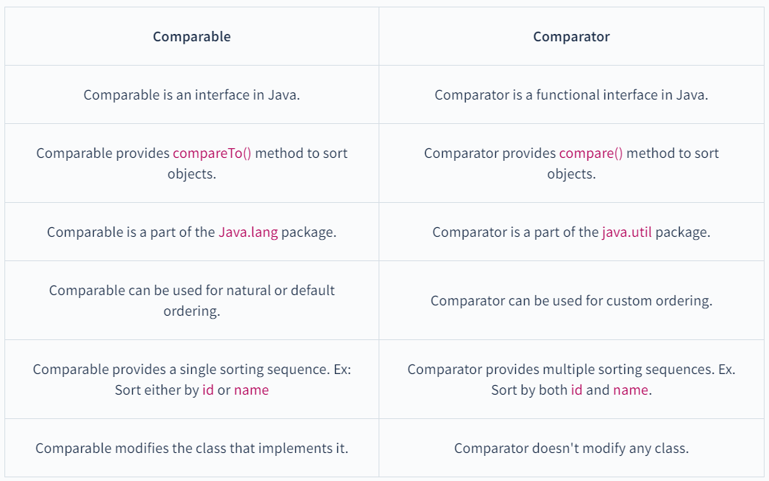

- All Wrapper classes & String class implements Comparable, that’s why Collection.sort() directly sorts the data with Wrapper or String class.
- Collator & RuleBasedCollator implements Comparator.
- In Java and using Spring boot framework, I've a scenario where my one service is calling 3 external Microservices, now I need to call these Microservices simultaneously or we can say in parallel and then we need to collate the response from all the services and store in DB, how can we achieve this?

To call multiple external Microservices in parallel and then collate their responses in a Spring Boot application, you can use Java's multithreading capabilities. Here's a high-level overview of how to achieve this:

- Create a Service Class:
  - Start by creating a service class that will orchestrate the parallel calls to the external Microservices and handle the response collation. This service class should be annotated with `@Service` if you're using Spring.

- Use Java's Executor Framework:
  - You can use Java's Executor framework to submit tasks that will call the external Microservices in parallel. Spring provides integration with this framework.

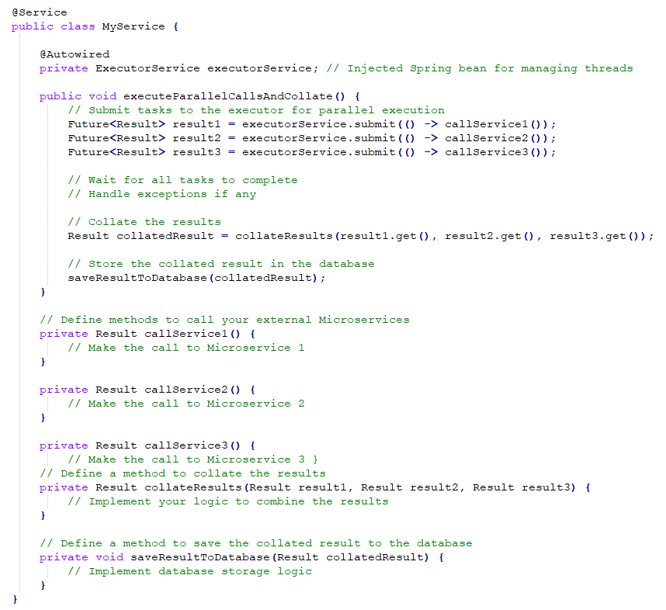

- Configure Executor Service:
  - Configure the `ExecutorService` bean in your Spring configuration. You can control the number of threads and other properties according to your requirements.

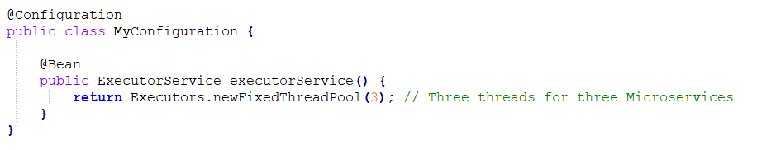

- Error Handling:
  - Be sure to handle exceptions and errors appropriately for each Microservice call and when collating the results.

- Dependency Injection:
  - Ensure that you have the necessary dependencies and configurations for Spring Boot, such as the `@Autowired` annotations and the necessary properties to configure the external Microservice endpoints.

With this setup, your Spring Boot service will call the three external Microservices in parallel using multiple threads, collate their responses, and save the result in the database. Make sure to customize the code and error handling logic according to your specific use case and requirements.

- Which constructor you can call using super() keyword in Java.
- In java, you can call both argument & no argument constructor, provided that it should be the first statement in the constructor body. This is because the superclass's initialization should happen before the subclass's initialization.
- You can use the super keyword to call constructors from the superclass (parent class) of the current class.
- If you don't use super to explicitly call a constructor in the subclass constructor, Java will insert an implicit call to the no-argument (default) constructor of the superclass.
- When you don’t call super keyword implicitly, compiler will add the super call to no argument constructor of its immediate parent class.

- How to you handle Global Exceptions in Spring Boot.
Handling global exceptions in Spring Boot involves creating a custom exception handler that can catch exceptions thrown from anywhere in your application and provide a consistent response to the client. Here are the steps to handle global exceptions in Spring Boot using Java:

- Create Custom Exception Classes:
  - Define custom exception classes that represent the specific types of exceptions you want to handle globally. These classes should typically extend `RuntimeException` or any other exception type that suits your needs.

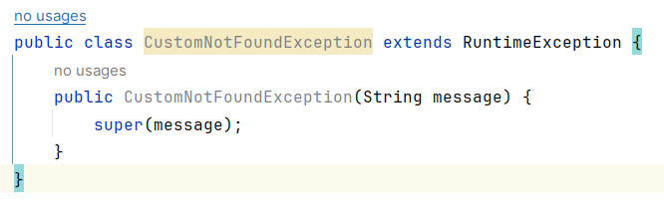

- Create a Global Exception Handler:
  - Create a global exception handler class that annotates a method with `@ControllerAdvice`. This class will handle exceptions thrown from any part of your application.

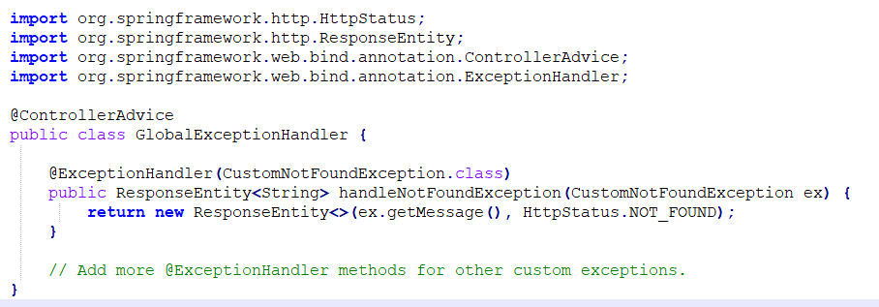

- Define Exception Handling Logic:
  - Inside the `GlobalExceptionHandler` class, create methods annotated with `@ExceptionHandler` for each custom exception type you want to handle globally. In these methods, you can define how to handle the exception and return an appropriate response, such as an HTTP status code and an error message.

- Throw Custom Exceptions:
  - In your application code, throw the custom exceptions when an error condition occurs. For example:
  - When the `CustomNotFoundException` is thrown, the global exception handler will intercept it and return a custom response.

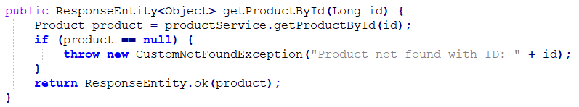

- Class loaders in Java.
- Bootstrap Class Loader (Primordial Class Loader): This is the parent of all class loaders and is responsible for loading core Java classes, including those in the java.* packages. It is implemented in native code and is not written in Java. You typically do not interact with this class loader directly.
- Extension Class Loader: Also known as the platform class loader, it loads classes from the standard extension directories (usually located in the jre/lib/ext directory) and is responsible for classes in the javax.* and java.* packages. You may encounter it when working with Java extensions.
- System Class Loader (Application Class Loader): This is the class loader responsible for loading classes from the classpath specified when starting a Java application (e.g., with the -classpath or -cp option). It loads classes for your application.

- Explain practical use of prototype scope.
In a Java Spring Boot project, you can use the "prototype" scope for a bean by annotating it with `@Scope("prototype")`. This ensures that a new instance of the bean is created each time it is requested from the Spring container. Here's a simple example:

- Create a Prototype-Scoped Bean Class:

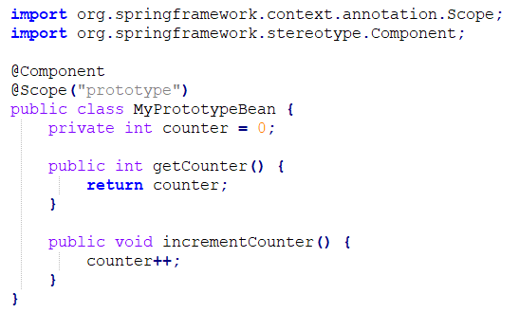

- Create a Service Class That Uses the Prototype Bean:
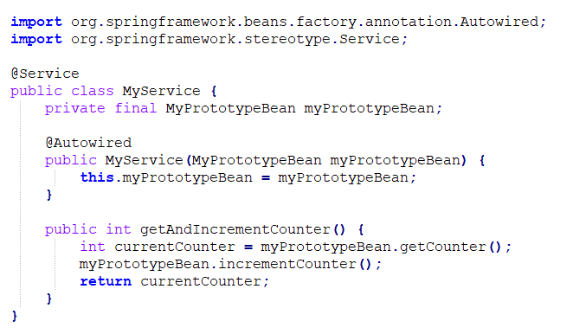
- Use the Prototype Bean in a Controller:
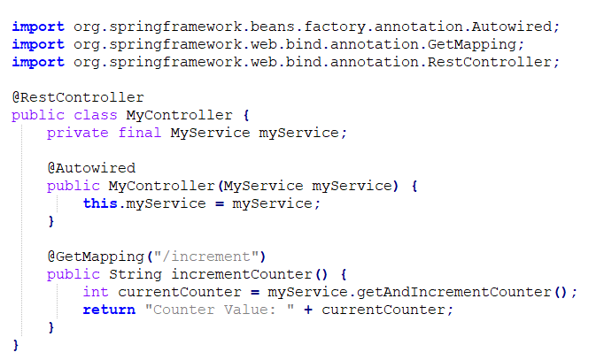

In this example:

    - We define a `MyPrototypeBean` class with the `@Scope("prototype")` annotation, indicating that it's a prototype-scoped bean.
    - The `MyService` class uses `MyPrototypeBean`, and it's injected via constructor injection.
    - The `MyController` class exposes an endpoint that calls the `getAndIncrementCounter` method of `MyService`, effectively using the prototype bean.

When you access the `/increment` endpoint, you'll see that the counter value starts from 0 and increments with each request. This demonstrates that a new instance of the `MyPrototypeBean` is created for each request, as expected with the prototype scope.

- Access modifiers in Java.

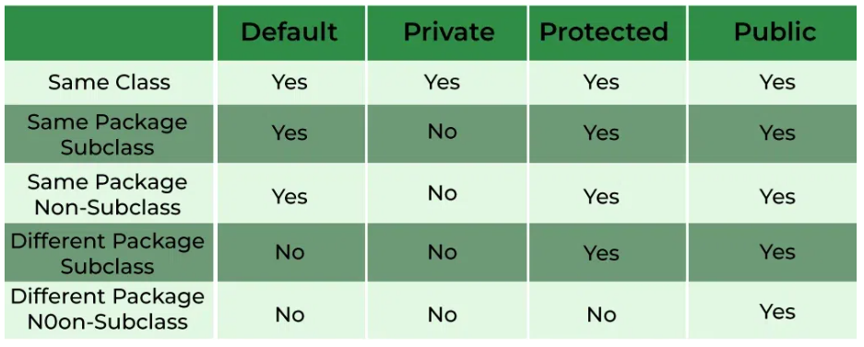

- How to implement Eureka Server (Service Registry) in Java Spring Boot Project.

- Create a New Spring Boot Project:
    - Start by creating a new Spring Boot project using a build tool like Maven or Gradle. You can use Spring Initializr (https://start.spring.io/) to generate a project template with the necessary dependencies.

- Add Eureka Server Dependency:
    - In your project's `pom.xml` file, add the Eureka Server dependency:
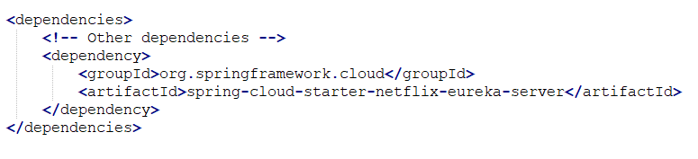
- Enable Eureka Server:
    - In your main application class, add the `@EnableEurekaServer` annotation to enable the Eureka Server functionality. This class should look something like this:

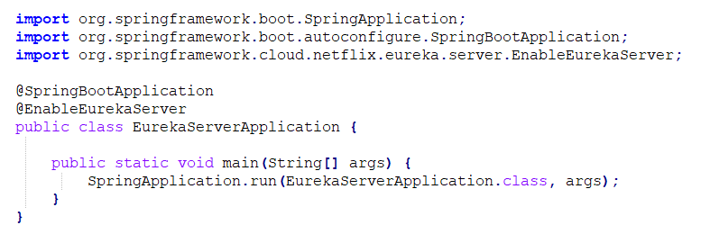
- Configure Eureka Server:
    - Create a `application.properties` or `application.yml` file to configure the Eureka server properties. Here's an example YAML configuration:
    - In this example, we've disabled registration and fetching of the registry for the Eureka server itself because it acts only as a server, not a client

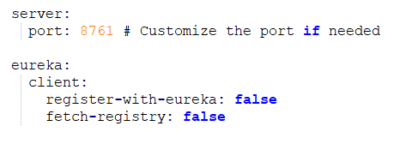

- Run the Eureka Server:
    - Start your Spring Boot application, and the Eureka Server will be up and running on the specified port (default is 8761).
    - Access the Eureka Server's web console by navigating to `http://localhost:8761` in your web browser. You should see the Eureka dashboard with service instances once services start registering with it.

- 6. Register Client Services:
    - To use Eureka for service registration and discovery, create other Spring Boot microservices and configure them to act as Eureka clients. These services will register with the Eureka server, making their endpoints discoverable by other services.

- 7. Configuring Eureka Clients:
    - In your Eureka client applications, add the `spring-cloud-starter-netflix-eureka-client` dependency.
    - Configure the client to connect to the Eureka server by specifying the server's URL in the `application.properties` or `application.yml` file:
    - The `defaultZone` property should point to the Eureka Server's location.
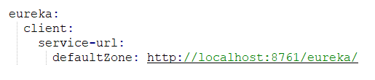

- Run Eureka Client Services:
    - Start your Eureka client services. They will automatically register themselves with the Eureka server.

- Verify Service Discovery:
    - Go back to the Eureka Server's web console (`http://localhost:8761`) to verify that the registered services are listed and healthy.

- Use Service Discovery:
    - In your microservices, you can now use service names (registered with Eureka) instead of hardcoding URLs to interact with other services. Eureka will handle the dynamic resolution of service endpoints.

